CPU DIAGRAM

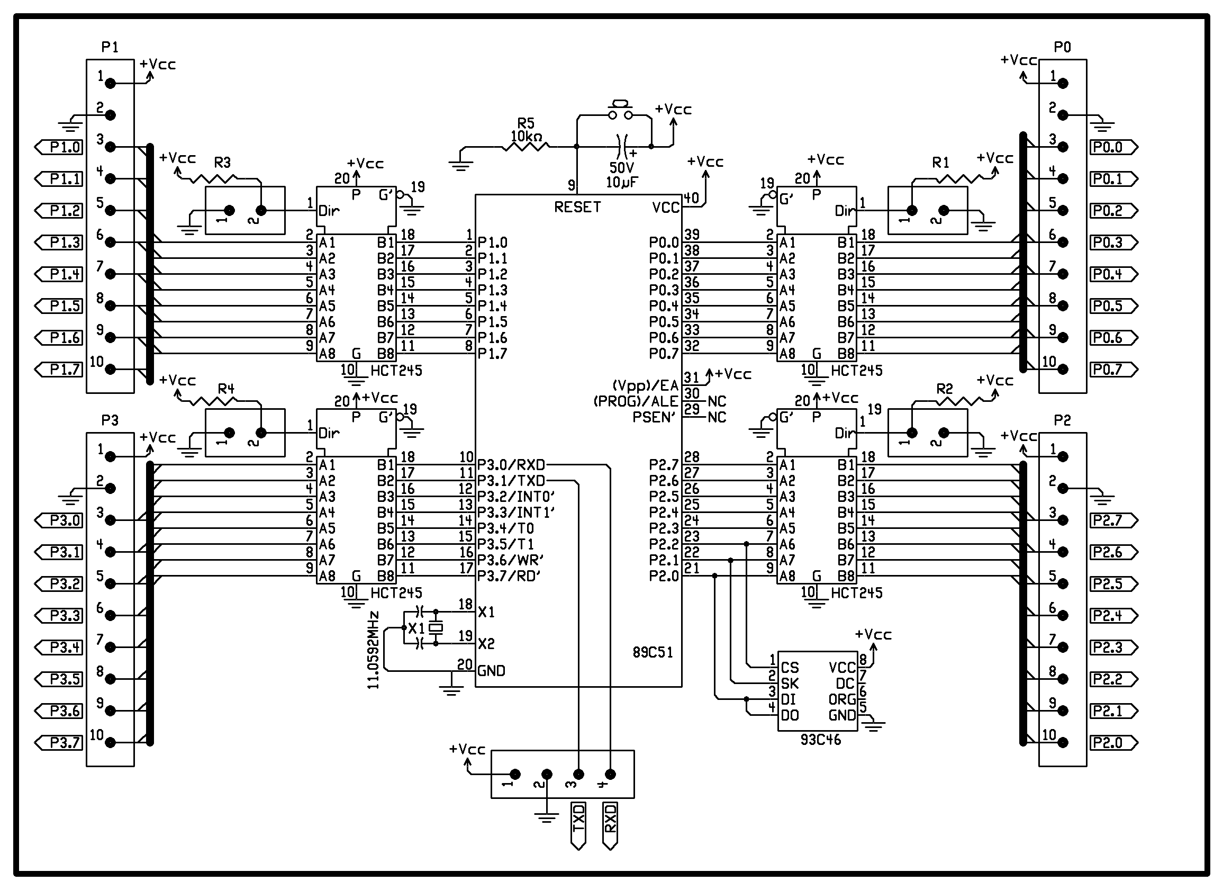

EXPLANATION:

The 89C51 is an 8-bit flash Microcontroller. It has 4 I/O ports and all ports are general I/O Ports. The port 3 is a serial port for connecting any serial devices and it is also used for interrupts. The fan out (output current) of the microcontroller is 10mA and if the connecting I/O devices require the current which is more than 10mA this may create overload to the microcontroller and can damage the microcontroller. So to avoid this, a buffer HCT245 is connected to the every ports of the microcontroller.

The HCT245 is an 8-bit bi-directional buffer and is connected to the 8 pins of the ports. The pin 1 is enable pin connected to the Vcc through resistor. The pin 9 is the RESET pin of the microcontroller and is connected to the switch. Whenever a high pulse is applied to the RESET pin, the microcontroller jump to the address location 0000H and commence running from there. The capacitor connected to the RESET pin is charges and discharges through the Vcc which auto resets the microcontroller.
Buffers also provide isolation between microcontroller and I/O devices which helps the microcontroller to operate in normal mode and the chances of program corruption can be avoided. The total power supply required the circuit is 5V and depending on the sensors, relays, motors the current consumption has been decided. If the I/O requirement is more than the fan out of buffer a transistorized relay switching need to connect.

